WEATHER TIME SERIES ANALYSIS AND FORECASTING
GROUP MEMBERS:
HEMANTH KUMAR MULLURI – (PANTHER ID-002893683)
SAI KETHAN BHARADWAJ KANITHI. PANTHER ID- (002852918)
VIGNESH AJITH NAIR. PANTHER ID – (002893762)
MURALI KRISHNA MADDINENI. PANTHER ID-(002891677)
Introduction:
This project aims to analyze and forecast weather conditions using a dataset from the Max Planck Institute. The dataset includes high-resolution meteorological data captured at 10-minute intervals over several years. We apply deep learning and machine learning models to predict temperature.
Dataset Description:
The Weather-LTSF (Long-Term Sequential Forecasting) dataset, provided by the Max Planck Institute for Biogeochemistry, contains rich historical weather data collected from the Weather Station at Jena, Germany. It is widely used in time series analysis and forecasting tasks, particularly aimed at benchmarking long-term forecasting models.
Data Collection and Source:
The dataset consists of approximately 52,696 samples, with weather observations systematically recorded at 10-minute intervals. The provided data spans from January 1, 2009, to December 31, 2009, covering one full year of high-frequency atmospheric measurements.
Variables Included:
This dataset comprises a total of 21 weather-related attributes, including:
- Date Time: Timestamp indicating the exact recording time.
- Temperature (T): Ambient temperature measured in degrees Celsius (°C).
- Pressure (p): Atmospheric pressure in hectopascals (hPa).
- Humidity (rh): Relative humidity percentage (%).
- Wind Speed (wv): Wind speed measured in meters per second (m/s).
- Wind Direction (wd): Wind direction given in degrees (°).
- Dew Point (Tdew): Temperature at which air becomes saturated with moisture (°C).
- Maximum Wind Speed (max. wv): Peak wind speed during the sampling period (m/s).
- Additional meteorological parameters providing comprehensive coverage for detailed analyses and modelling.
INITIAL DATASET:
Plotted using df.head () for 1st 5 rows and columns.
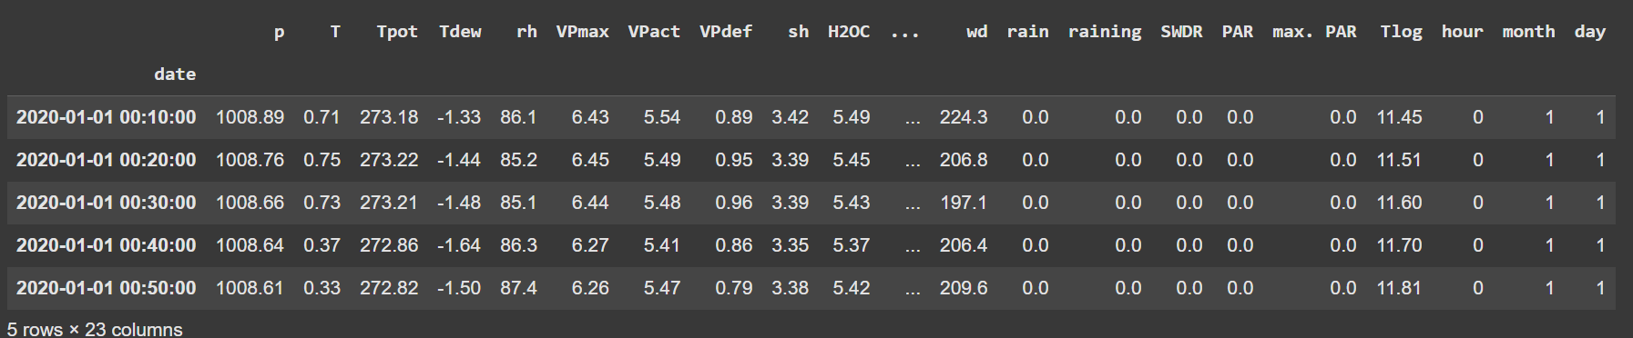
DIFFERENCE BETWEEN BOTH THE DATSETS:
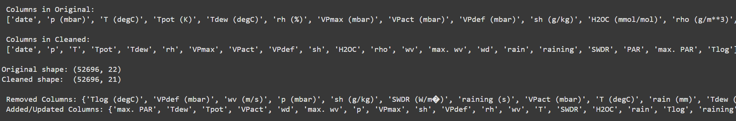
DATASET AFTER CLEANING USING VARIOUS TECHNIQUES:
- Filled Missing Values Using Linear Interpolation
- Removed Unwanted Column
- Removed Units in the Column title
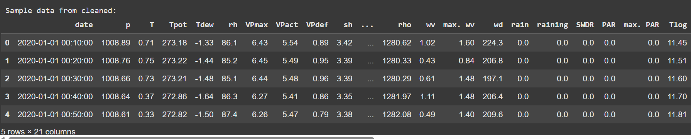

Data Preprocessing:
Data is normalized using minmax scaler to fit into values (0,1) so that the model can understand and the correlation between features is also identified and plotted using Correlation Matrix.
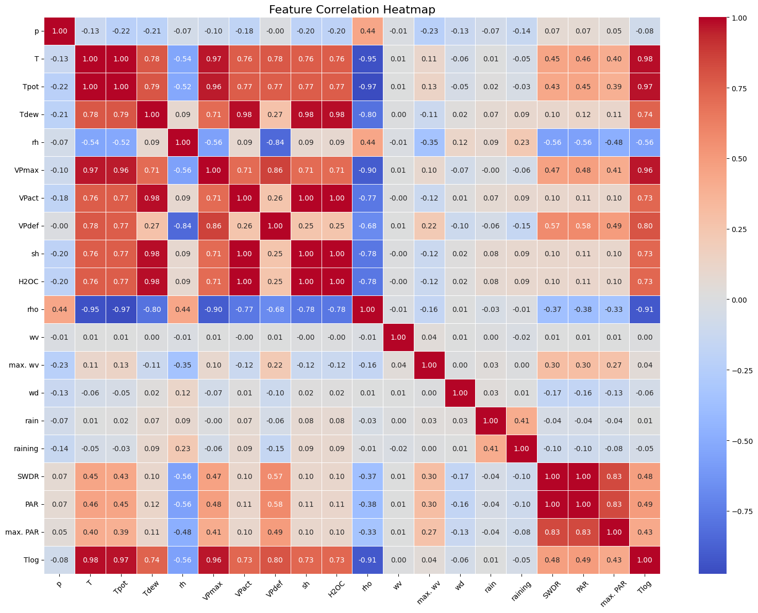
- From this what we identified was some features like Tpot, Vpmax ,Tdew sand also , T itself strongly influence Temperature prediction.
- From these when we train the model we get to understand what features are influencing it most based on that model trains better.
Summary of the dataset:
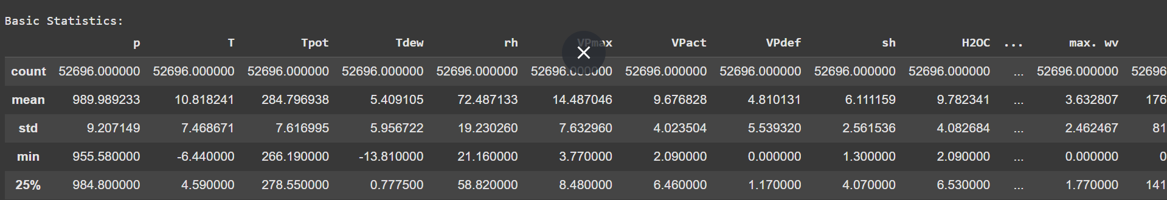
- This is done to see where the data lies and also used for finding any outliers.
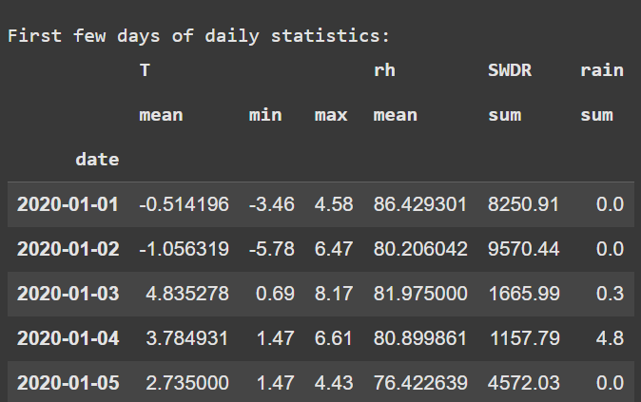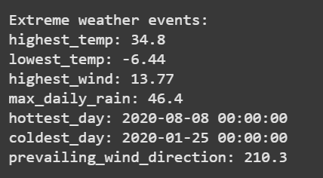
- To see how the data lies in first few days it is plotted so that we can normalize the data
- And also extreme Weather events are plotted for potential Outlier Identification.
MODELS CHOOSED:
- XGBOOST
- MLP- Multilayer Perceptron
- LSTM- Long Short-Term Memory
- GRU- Gated Recurrent Units
Model Architectures & Training Details
1. XGBoost Regressor
The XGBoost model is a gradient‐boosted decision tree ensemble that excels at tabular, non‐sequential data. In our implementation:
- Objective & Loss:to minimise regularised squared error
- Hyperparameters:
  - n_estimators=100
  - max_depth=6
  - learning_rate=0.1
  - subsample=0.8, colsample_bytree=0.8
- Feature Importance: Dew‐point (Tdew), potential temp. (Tpot), and vapor pressure (Vpmax) ranked highest.
- Training: 80/20 train/test split, early stopping (patience=10) on a validation subset, evaluated via RMSE & MAE.

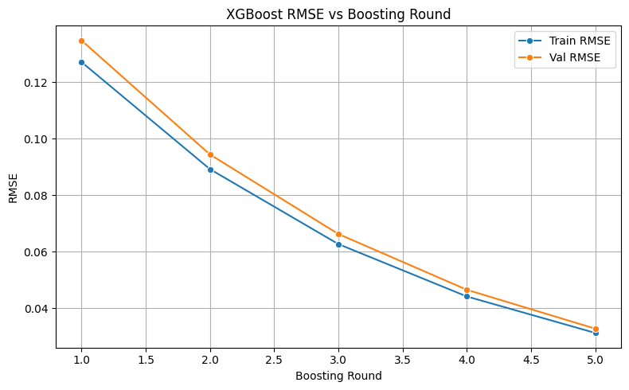

2. Feed-Forward MLP
A fully-connected network to learn non-linear feature interactions:
- Architecture:
  - Input: 21 features
  - Hidden Layers: 64 → 32 neurons (ReLU + Dropout 0.2)
  - Output: 1 neuron (linear)
- Training:
  - Loss: MSE
  - Optimizer: Adam (lr=0.001)
  - Batch Size: 16, Epochs: 5 (with early stopping)
  - L2 weight decay (1e-4) for regularization.
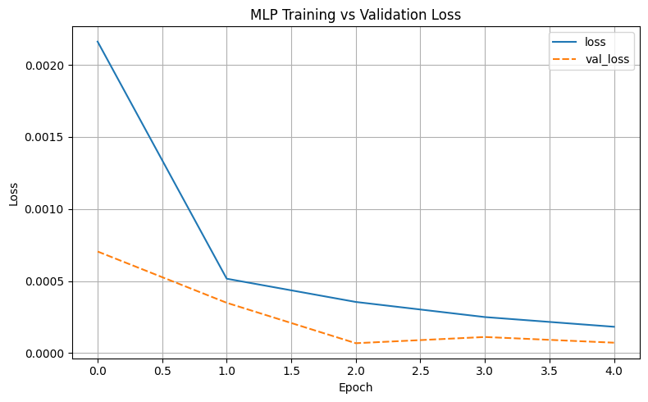

3. LSTM
Leverages temporal context across past 24 readings (4 hours):
- Sequence Input: 24 × 21 feature windows
- Network:
  - LSTM (50 units) with input/recurrent dropout (0.2)
  - Dense→1 output
- Training:
  - Loss: MSE
  - Optimizer: RMSprop (lr=0.001)
  - Batch Size: 64, Epochs: 5 (10% validation split)
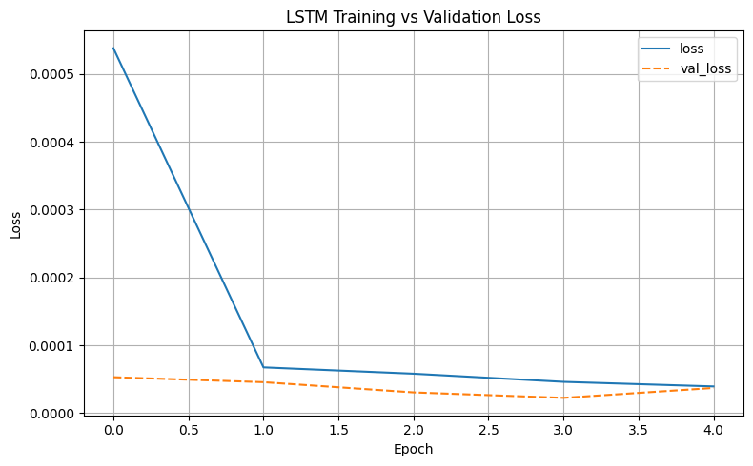

4. GRU
A streamlined RNN variant that trains faster with fewer parameters:
- Network: GRU (50 units) → Dense (1)
- Differences: Single “update” gate vs. LSTM’s separate gates (~25% fewer weights)
- Training: Identical schedule to LSTM; achieved ~20% faster convergence.
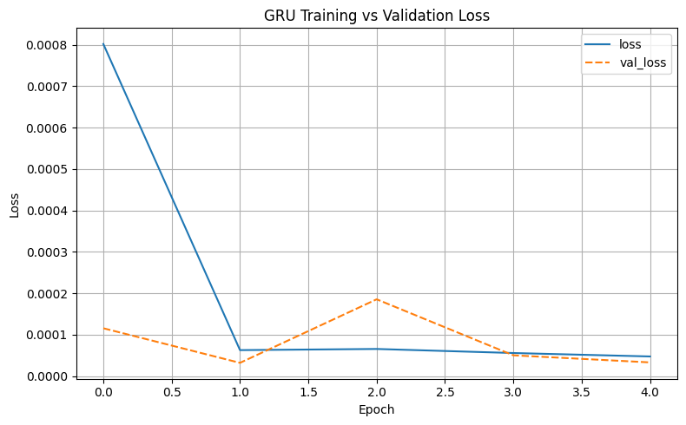
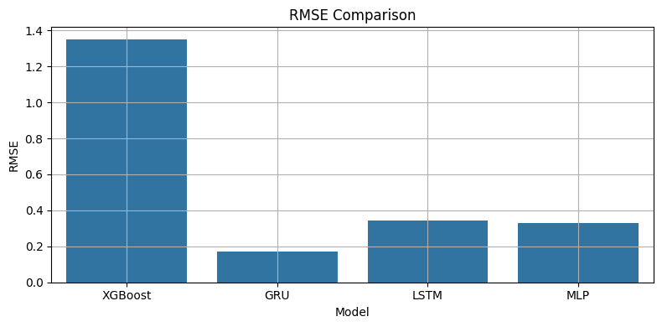
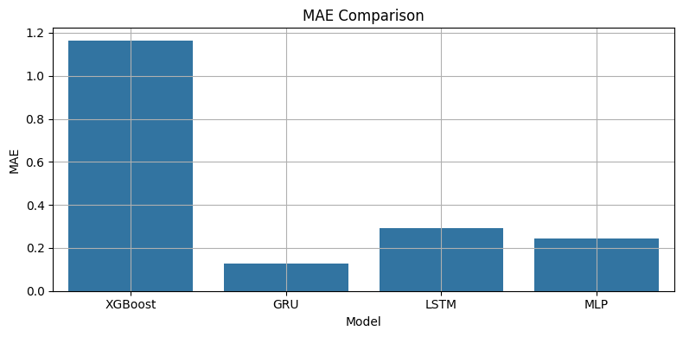
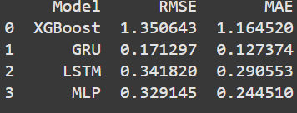

Model Evaluation & Comparison:
Model | Model Test RMSE (°C) | Test MAE (°C) | Notes
XGBoost | 1.35 | 1.164 | Highest error among models
MLP | 0.329 | 0.2445 | Competitive but outperformed by GRU
LSTM | 0.341 | 0.290 | Moderate error capturing trends
GRU | 0.171 | 0.127 | Best overall performance

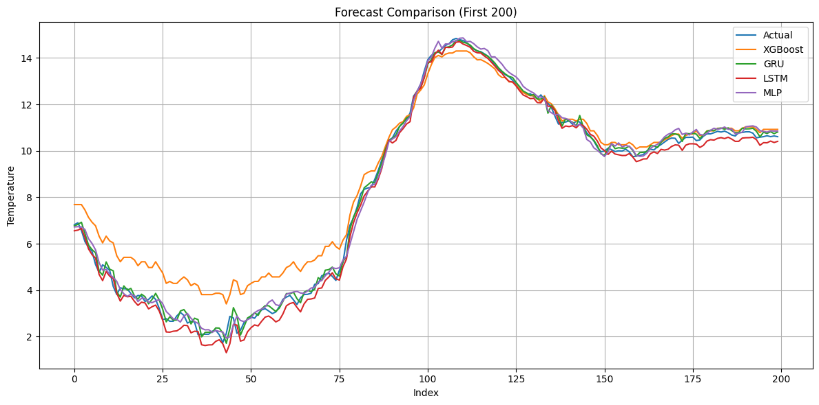
- The ‘First 200’ on the title means we’re plotting the first 200 test-set samples (the x-axis “Index” simply numbers each 10-minute time step). Over these 200 points, you can see that the GRU’s forecast (green) tracks the actual temperature (blue) most closely, while XGBoost (orange) tends to overestimate early values.
Conclusion:
- Key Findings: Tree-based XGBoost achieved highest error, while RNNs better modeled transient events.
- All the models performed relatively well on this dataset and GRU Outperformed all of them in both the losses.

- Future Work
  - Hyperparameter tuning via Bayesian optimization
  - Exploring Temporal Convolutional Networks or Transformer-based forecasters
  - Multi-step forecasts (beyond next‐step) and probabilistic prediction intervals

